**Workflows**

***Simulations on Speedy2***

Can run simulation right from Repast Simphony. Click green button to open model then yellow button for batch runs.

The host properties should look like so:

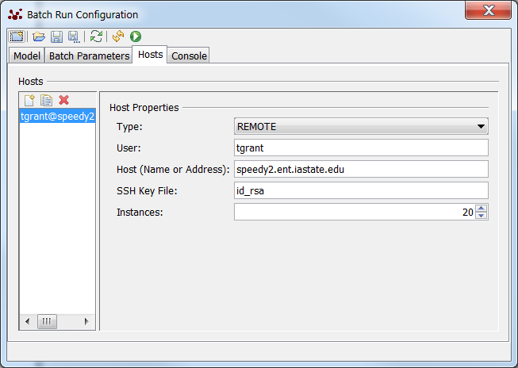

Check how things are going with <http://www.biology-it.iastate.edu/status/speedy2>

I usually add more memory in model screen as –Xmx8092M.

Be sure to add space-separated list of agents per instance in the batch parms window.

Or log in to speedy2 using PuTTY and my ISU credentials (same as for email, etc.). Use commands top or atop to see how the cores are doing. Press Q to get out of top.

If the connection from RS to the server is lost, you have to go through several steps to get the output files. The simulation will finish and the output files will be in their individual instance folders. You have to copy jsch-0.1.48.jar to the lib directory of the simulation. This jar is normally in C:\RepastSimphony-2.3.1\eclipse\plugins\repast.simphony.distributed.batch_2.3.1\lib. I copied it to Downloads folder to move it easier using pscp. Then the scripts have to be activated as it describes in the batch runs .pdf, using the command chmod +x *.sh. Then the outputcombiner can be run, from the folder where you can see the instance folders and lib folder, using ./outputcombiner.sh. Then use pscp to copy the combined_data folder from the server to my laptop:

"C:\Program Files (x86)\PuTTY\pscp.exe" –r tgrant@speedy2:/home/tgrant/simphony_model_14etc/combined_data/* C:\Users\tgrant\Downloads\.

*Linux/speedy2/PuTTY commands*

Dir – ll; change dir – cd; head, cat – read text files; cd .. go back one dir

***Egg Density per Polygon Workflow***

Import the CumEggsPerZone text output file from the simulation. The “Denresults” dataframe combines all the data for each polygon, because there is independent data from each simulation. Various statistics are added to the dataframe for each polygon.

Extract just the data on each habitat type from Denresults. For sensitivity analysis, I’m just doing MWROW60-100 and Grass/Pasture. Look at the distribution of egg density per ha for polygons of each habitat type and calculate mean, median, SD, etc.

Start a graph that will show mean and median egg density per habitat type, per simulation.

Throw mean and medians into response variable vectors for global sensitivity analysis script file (a separate file).

***Utilization Distribution workflow***

*To run on speedy2:*

Copy the coords output file to speedy2 using pscp from the Windows Command Prompt:

"C:\Program Files (x86)\PuTTY\pscp.exe" C:\Users\tgrant\Downloads\file tgrant@speedy2:/home/tgrant/R/.

Login to speedy2 with PuTTY and ISU login credentials. Find speedy2UDscript.R in Yeti output folder on my computer (C:\Users\tgrant\Documents\Monarch Butterflies\Modelling with Repast Simphony\Output from apr28 and prev).

Follow speedy2UDscript.R workflow.

Create R objects of dbbmms and areas and copy them from speedy2 using pscp. (Only really need to copy the area, can copy dbbmms if need to check up on things.)

***Mean Eggs Laid Workflow***